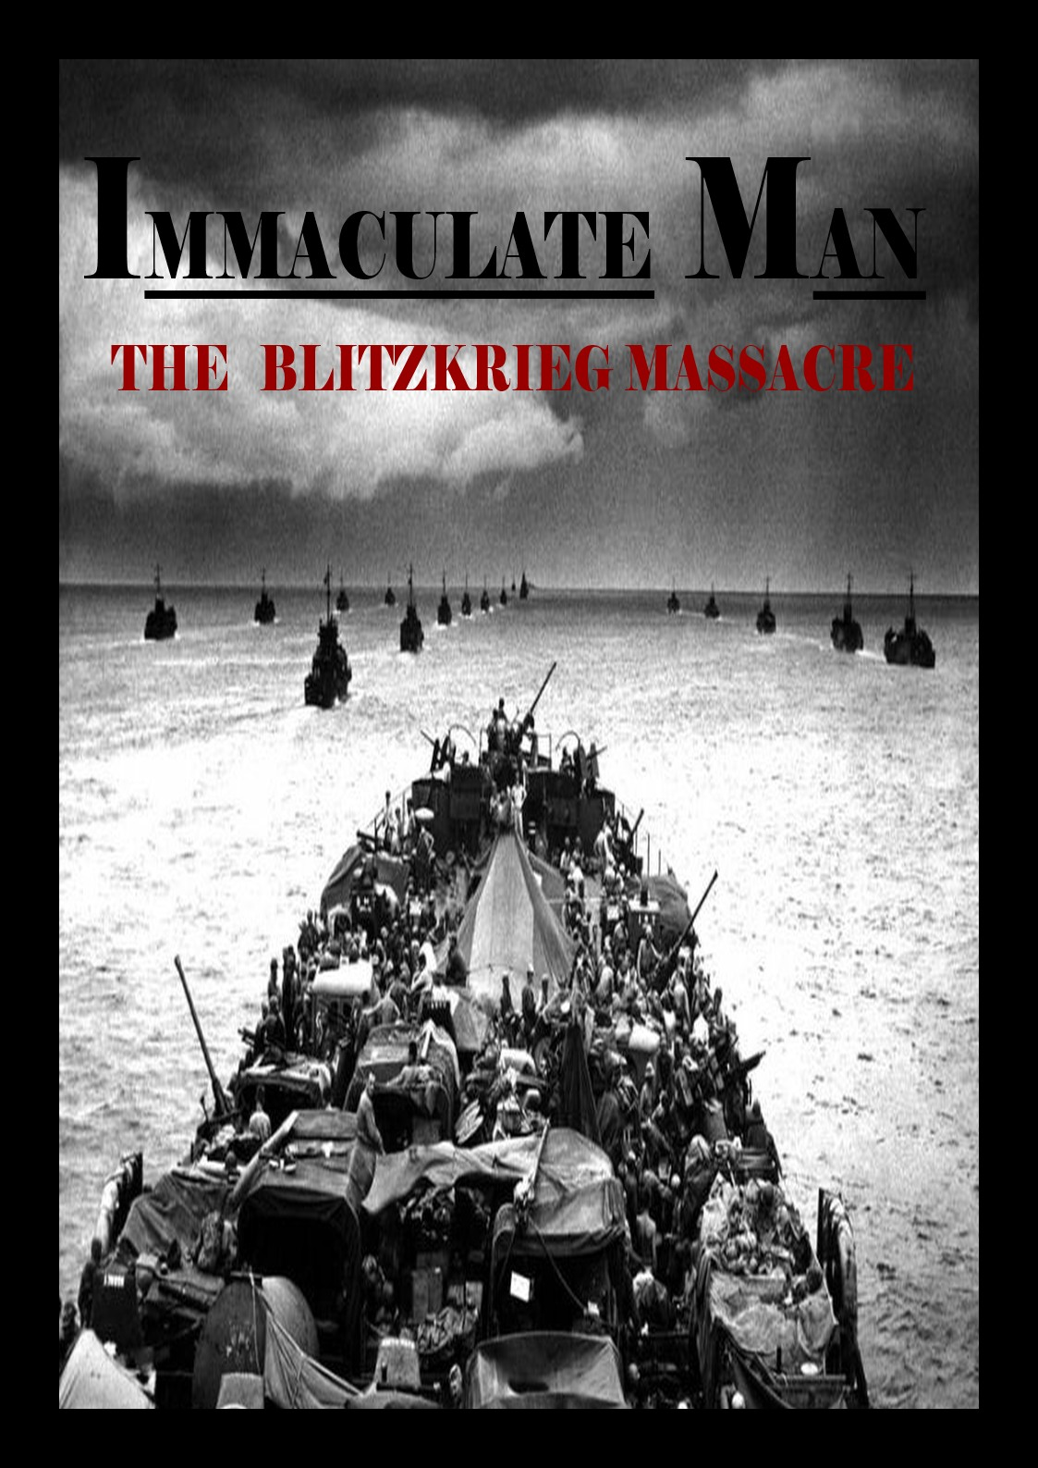

A young boy stared outside the widow looking at the ramshackling remains of a moribund city whilst sitting on a broken and asperous cement block. After a long-awaited small period of long silence passed by him, he saw a small bright light flicker in the distance as it fell from the night sky. The bright yellow light eventually disappeared and became part of the remains that overlaid the city. Seconds after the bright light ceased to exist, a moderately close bold and heavy rolling voice quietly said “Shmuel, come down before it gets dark”. Shmuel quickly ran down the pile of rubble and into the underfoot bunker with the man who called for him. As he hurryingly walked in the thick led door was shut behind him by the man, Shmuel then sat down to the daily misfortune of having to feast on half rotten spinach soup from a tin can. The man then stood beside the slightly young, guileless Alicja and said in a slightly rough voice “I hope everyone is ready for tomorrow, we need to get to the resistance as soon as possible, I hear that heading south in the area of Lindau is the safest way” he said as he ate half a cracker before placing the other half in his pocket. After a long, uncomfortable, silent dinner a loud siren noise came echoing throughout the city. Papa quickly ushered the kids to the hard-featured, stannic bunk bed. Hurriedly, he ran towards the bunker’s door and reassured that the all the locks were properly sealed. In no time, the floor shook repeatedly, like a giant stomping on a midget’s house. As the explosions got louder and louder, the kids curled up even more in their beds with their cotton blankets. As Shmuel lay in his bed with tears of fear running down the side of his face and through the stained white pillow, Alicja’s arm grabbed Shmuel’s hand and she said in a silent tone “don’t be scared, it will end, no matter what everything comes to an end, even the bad things, you’ll see”.

After a short night riddled with falling bombs and constant insomnia, the morning finally came, and the noise stopped. Shmuel slowly made his way out of his bed, struggling to put on his brown rugged clothes whilst Alicja helped papa pack the essentials. The four of them eventually started their journey through the war-shattered country to find the remains of the resistance. Not too long after having started their journey they encountered a strange young man scavenging the remains of what looked like an abandoned truck. Papa kept his distance, the strange man slowly turned towards them before wielding a long rusty sword. As more sword carrying scavengers started surrounding Papa and the children the strange man got increasingly rabid. “hand your stuff over and no harm will be done” said the man as they got closer and closer. Suddenly a series of gunshots were fired close by and one of the scavengers yelled “Laufen die Schutzstaffel sind hier“ and they ran away. As Papa and the family tried to run as far as they could the Schutzstaffel caught up to them and held them at gun point. Eventually one of the black uniformed soldiers searched papa and pulled out his passport. “How strange, I see you have a polish name but it says also that you are an Englishman, now in that case no wonder we caught to you so easily, hell shooting the scavengers was more difficult than catching you” said the soldier as he quickly flicked the pages of the passport. “look we mean no harm just please let us go” said Papa in fear. “Lugner, you people are poison, I believe the English have a special word, Scum, that is what you are” shouted the soldier at Papa before kicking him to the ground. Shortly after the four of them had their hands tied behind their back before being neglectfully stuffed into the back of an armoured truck along with other prisoners.

